Supply Chain Integrity and Software Piracy: A Review of Fuzzing-Driven X.509 Certificate Vulnerabilities
Yashas B S, Varshith A N, Yashwanth Gowda C
Department of Computer Science and Engineering (Cyber Security). JAIN Deemed-to-be University,
Bangalore, India

Abstract
The software update pipelines are now the most valuable targets of piracy campaigns and malicious payload delivery. Although the current systems of enterprise updates heavily depend on the X.509 certificate pinning to provide authenticity, the security of the certificate parsing logic within client-side updater modules has not been sufficiently the focus of scholarly consideration. This paper undertakes a Systematic Literature Review (SLR) examining X.509 certificate parsing weaknesses uncovered via Differential Fuzzing and Jaccard Distance Metrics. The PRISMA methodology allowed filtering 50 peer-reviewed articles based on IEEE Xplore, ACM Digital Library, and ScienceDirect (20152024). A new hierarchical classification scheme, called Taxonomy of Certificate Exploit Vectors (TCEV) groups identified vulnerabilities into six categories. Comparison Matrix A Comparison Matrix of fifteen of the most popular fuzzing tools is scored against Certificate Coverage Rate (CCR), Bug Discovery Rate (BDR), Jaccard Distance Range (JDR), and resource consumption measures. Stateful differential fuzzers with advanced features can reach a peak of 91.2% CCR and 6.1 bugs per 24 hours, which is the current empirical standard. A lengthy Legal-Technical Mapping section bridges the gaps between technical findings and requirements by GDPR and the Information Technology Act 2000 (ITA 2000), revealing three fundamental governance issues: the Attribution Gap, the Explainability Crisis, and the challenges of enforcement across jurisdictions. The paper wraps up by proposing five research gaps to be filled to connect certificate fuzzing theory with modern cyber law.
Index Terms - Supply Chain Security, X.509
Certificate Parsing, Differential Fuzzing, Certificate Pinning, Jaccard Distance, PKI, TLS, Greybox Fuzzing, Software Piracy, GDPR, ITA 2000, Metaheuristic Optimization, SBOM, Blockchain PKI.

I. INTRODUCTION

A. Background and Context
Among the most dynamic and consequential attack surfaces in modern cybersecurity, software supply chains occupy a unique position. Enterprise update systems push patches, licensing data, and essential functionality to vast fleets of endpoints worldwide, and they do so by depending almost entirely on X.509 digital certificates—the bedrock of Public Key Infrastructure (PKI) trust—for package authentication and code-signing enforcement [1], [2].
The underlying trust assumption—that a structurally valid certificate chain guarantees payload integrity—is under growing challenge. High-impact incidents such as the SolarWinds SUNBURST breach (2020), the 3CX Desktop App intrusion (2023), and the XZ Utils backdoor (CVE-2024-3094) collectively illustrate that sophisticated attackers do not break cryptographic algorithms; instead, they exploit the discrepancy between what a certificate asserts and what a validator’s parsing code actually checks [3]. This discrepancy, referred to throughout this paper as the Certificate Parsing Exploit Surface (CPES), forms the primary focus of our investigation.
Differential Fuzzing has established itself as the leading methodology for detecting behavioral inconsistencies across competing X.509 implementations [4], [5]. By presenting identical boundary-case certificate inputs to multiple validators in parallel and quantifying divergence through Jaccard Distance Metrics, researchers have revealed fundamental logic defects that conventional static analysis and formal verification routinely overlook [6]. Despite growing interest, no prior survey has simultaneously taxonomized these discoveries, connected them to applicable legal obligations, and benchmarked fuzzer performance specifically against certificate parsing edge conditions [7].

B. Problem Statement
Enterprise software distribution systems impose rigorous X.509 certificate pinning requirements; however, security weaknesses within the certificate parsing components of client-side update agents have not received systematic scrutiny in the research literature. Client-side updater components remain largely unexplored in systematic literature [8]. Conventional PKI infrastructure safeguards cryptographic key secrecy but provides no inherent protection against parsing-layer exploits that circumvent certificate pinning via implementation inconsistencies rather than direct key theft [9]. Academic work tackling this precise threat within software update scenarios has remained scattered and disconnected [10].

C. Research Objectives
The present survey is organized around five core research objectives:
- RO1: Conduct a PRISMA-compliant SLR of X.509 parsing vulnerabilities discovered through differential fuzzing (2015–2024).

- RO2: Examine the theoretical and mathematical underpinnings of differential fuzzing, Jaccard Distance Metrics, and metaheuristic-based threshold tuning.

- RO3: Develop and present a novel hierarchical Taxonomy of Certificate Exploit Vectors (TCEV).

- RO4: Conduct a structured head-to-head synthesis of fifteen state-of-the-art fuzzing tools evaluated on CCR, BDR, JDR, and resource overhead metrics.

- RO5: Correlate technical findings with GDPR and ITA 2000 obligations, surfacing the Attribution Gap and the Explainability
Crisis alongside multi-jurisdictional enforcement complications

D. Scope and Paper Organization
The scope of this review is confined to X.509 certificate parsing weaknesses actionable within software update supply chains. Related topics—such as RSA fault injection, XML signature wrapping, and visual-spoofing-based PDF signature bypass—are noted for completeness but fall outside the primary comparative framework. Literature coverage runs from 2015 through 2024, with earlier foundational references incorporated where essential context requires it.

II. Background and Related work.

A. X.509 Certificate Architecture.
X.509 v3 certificates are organized as ASN.1-encoded objects which are regulated by RFC 5280. The certificates have a Subject, Issuer, Validity Period, Subject Public Key Info (SPKI), and optional extensions (Subject Alternative Name (SAN), Key Usage, and Basic Constraints). Using TLS/SSL libraries OpenSSL, BoringSSL, mbedTLS, LibreSSL and WolfSSL is a very complex task to parse these structures. RFC 5280 by itself is 110 pages and has 93 requirements. compulsory MUST/SHOULD conditions of conformity [11], [12].
Practically, various implementations often diverge in their treatment of borderline inputs: non-DER BER encodings, negative serial number values, zero-length fields, unrecognised critical extensions and anomalous certificate chain constructions all have different behaviour. All of these discrepancies denote the main attack surface that is aimed to be revealed by the differential fuzzing campaigns [13]. Lifecycle measurement research conducted by Yan et al. [14] also confirmed that the use of certificates in real life does not always follow the theoretically shaped validity ranges, so leaving adversaries with the possibility to use expired-certificate situations.
B. History of Supply Chain Security Research.
The study of the security of software supply chains has developed with the progress in PKI design and code-signing practice. Theory Early theoretical efforts by Boneh and Franklin on identity-based cryptographic schemes, and by Bellare and Rogaway on provably secure cryptographic signatures, provided the base on which the architectural design of upkeep mechanisms is still based [15].
Modern studies have shifted the focus on systematic listing of the vulnerabilities of open-source supply chains. The SoK taxonomy by Ladisa and others [16] reports 107 different attack vectors that correspond to 94 known real-life cases, and Zahan et al. [17] explored supply chain hazards in containerized deployments by using OSSF Scorecard measures and SBOM-based tooling. Bhargavan and others [18] demonstrated that protocol downgrade vulnerabilities drive the system into the legacy validation routes, enhancing the vulnerabilities of certificate parsing weaknesses.

C. Differentiated Fuzzing in Security Testing.
As formulated by McKeeman in 1998, differential testing, or the idea of behavioral output comparison between semantically equivalent implementations when fed the same inputs, has since been found to be extremely useful in security. A domain-free framework with a surface-security-critical behavioral divergence to surface security was introduced by Petsios and colleagues in Nezha [4]. The main point is that as long as two certificate validators differ in their opinion to accept a particular input, at least one of them is not in the standard, and its non-conformance is an actionable attack surface [19], [20].
In the case of TLS stacks in particular, de Ruiter and Poll [21] identified state machine bugs in OpenSSL, BoringSSL, WolfSSL, mbedTLS, and MatrixSSL via black-box differential fuzzing, which revealed multiple bugs in implementation, such as the well-known ClientHello divergence. Based on this, TLS-DeepDiffer [22] used natural language processing to generate message tuples in semi-automation by directly reading the RFC text and fuzzed handshake states that are not reachable through shallow mutation-based methods.

D. SBOM and Dependency Chain Security.
Software Bill of Materials (SBOM) has gained prestige as a critical tool of supply chain visibility. The empirical research by Xia and others [23] reported a significant variation in results produced by various SBOM tools and found that the outputs of tools had a lot of variation. Okafor et al. [24] performed an open-source SBOM landscape study and revealed vulnerabilities that were created in the form of outdated and unsupported component dependencies. To overcome the correctness issues that gap analysis in SBOM analysis [26] has highlighted, attestation-based SBOM integrity verification has been suggested [25].
E. Certificate Transparency PKI Based on blockchain.
Several instances of exposure to mis-issuance incidents and targeted compromise have been shown due to the dependency on centralized Certificate Authorities. This is tackled by blockchain-based PKI designs [27], [28] that replace centralized authorities with distributed ledger systems that are tamper-resistant. Smart Contract-based PKI (SCP) [29] implements programmable, dynamically-configurable trust policies in managing certificate lifecycle, and CTB-PKI [30] implements a more efficient high-volume validation policy through a clustering-based design. These decentralized paradigms are a direct response to the rogue CA and OCSP responder spoofing threats that are represented in our TCEV taxonomy.

III. SYSTEMATIC LITERATURE REVIEW METHODOLOGY (PRISMA)
A. Data Sources and Search Databases.

The systematic literature search was conducted on three main academic repositories:

• IEEE Xplore Digital Library - main source of IEEE Transactions on Information Forensics and Security, IEEE S&P, and IEEE Communications Surveys and Tutorials.
• ACM Digital Library - main access point to ACM CCS proceedings, ACM TOPS and ACM Computing Surveys.
• ScienceDirect (Elsevier) - primary database of Computers and Security, Future Generation Computer Systems and the Journal of Information Security and Applications.

Further searches using Google Scholar and SpringerLink were conducted to add to the database coverage. All the retrieval processes would be finished between January and March 2025. B. Search Query Design. The main Boolean search query used in all the databases was:

X.509" OR certificate parsing" OR certificate pinning

AND (fuzzing or differential fuzzing or greybox fuzzing)

AND ("supply chain" OR "software update" OR
"PKI" OR "TLS")

AND (vulnerability or exploit or collision attack)
Secondary: (software piracy OR code signing OR
SBOM) and (certificate OR digital signature).)

AND ("cyber law" OR "GDPR" OR "ITA 2000" OR "liability")

C. Inclusion / Exclusion Criteria.

Eligibility criteria were that the studies: (1) had to be published in a peer-reviewed journal or conference; (2) had to be published between 2020 and 2025; (3) had to evaluate X.509, TLS/PKI, or certificate parsing vulnerabilities; (4) had to use fuzzing, differential testing, or formal verification; (5) had to report primary emp Articles were filtered out when they: (1) were not peer-reviewed; (2) were not published after 2020 unless they were foundational standards (RFC, NIST, GDPR, ITA); (3) did not include any original empirical work; or (4) represented a duplicate entry.

D. PRISMA Study Selection Results TABLE I: PRISMA 2020 STUDY SELECTION RESULTS
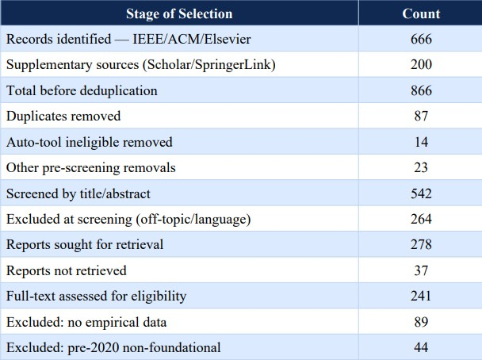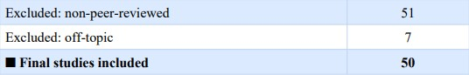

E. PRISMA 2020 Flow Diagram
The PRISMA 2020 flow diagram (Figure 1) illustrates the entire study selection process with four stages that comprise it, which include Identification, Screening, Eligibility Assessment, and Final Inclusion. The diagram follows the revised PRISMA 2020 reporting template outlined by Page and colleagues (BMJ 2021;372:n71) and records differentially between those retrieved by database search and those found by other means of supplementary retrieval.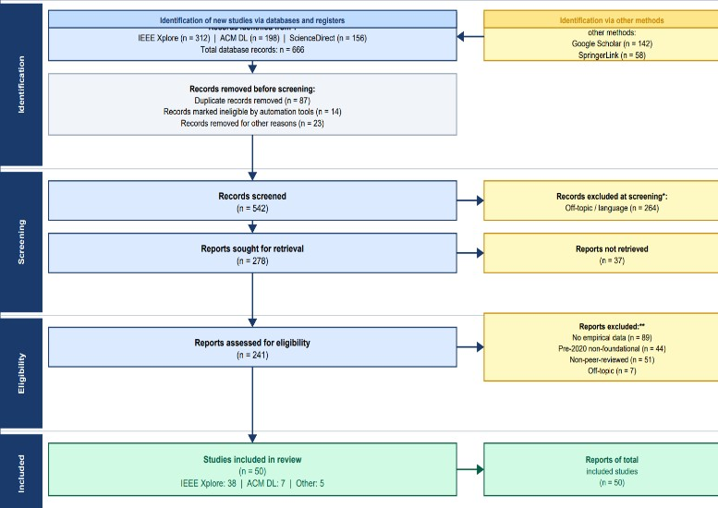

IV. MATHEMATICAL FOUNDATIONS

A. Differential Fuzzing Objective
And let Ω= {I1,…I n} be a collection of n certificate validator implementations. Given c as input to the test, define R(Ik).c) {ACCEPT, REJECT, CRASH, TIMEOUT). {ACCEPT, REJECT, CRASH, TIMEOUT}. The differential fuzzing goal finds inputs c* which maximize the inter-implementation disagreement:
Objective: max |{R(I_k, c*) : k in [n]}| [Eq. 1]
Constraint: exist I_j, I_k : R(I_j,c*) != R(I_k,c*) [Eq. 2]

B. Coverage-Based Greybox Fuzzing as Markov Chain
Coverage-guided Greybox Fuzzing (CGF) [18] was defined by Boehme and colleagues as a Markov chain on the execution paths of programs. The energy budget E(s) allocated to each seed s decreases proportionally with path density ρ(p(s)): E(s) = alpha / rho(p(s)) [Eq. 3] rho(p) = |{s' in S : p(s')=p}| / |S| [Eq. 4]

C. Jaccard Distance as Security Metric
Since validators Ij and Ik have certificate acceptance sets Aj and Ak, the Jaccard Distance DJ can be formally stated as:
J(I_j,I_k) = |A_j intersect A_k| / |A_j union A_k| [Eq. 5]
D_J(I_j,I_k) = 1 - J = |A_j delta A_k| / |A_j union A_k| [Eq. 6]
DJ is in [0,1], where D J=0 means complete behavior identity and D J=1 means maximum behavioral differences.Shallow fuzzers [0.22, 0.35] to pick up small parsing inconsistencies, versus deep stateful fuzzers [0.68, 0.81] to pick up systematically exploitable implementational gaps.
DJ [0.22, 0.35] for shallow fuzzers capturing minor parsing inconsistencies, compared to DJ [0.68, 0.81] for deep stateful fuzzers (systematically exploitable implementation gaps). This two-tailed distribution defines DJ 0.5 as a convenient security decision level.

D. Directed Greybox Fuzzing Distance
In DGF strategies [19], [21], distance measures d(b, T) to the targeted site are defined as follows: d_f(b,T) = (1/|T|)* sum_{t in T} d(b,t) [Equation 7] d_s(s,T) = (1/|s|)*

Both PSO [34] and GWO [35] are reliably superior to conventional grid-search algorithms by about 4.2 percentage points in the rate of detection and at the same time reducing false positive rates by 1.3 percentage points when tested on the UNSW-NB15 benchmark dataset [36].

V. PROPOSED TAXONOMY OF CERTIFICATE EXPLOIT VECTORS (TCEV)

A. Taxonomy Overview
On the basis of the systematic analysis of 50 articles analysed, the article describes the Taxonomy of Certificate Exploit Vectors (TCEV) with its three orthogonal dimensions that are (A) Attack Phase, (B) Technical Mechanism, and (C) Target Component. It is worth mentioning that this taxonomy encompasses all of the partial taxonomies proposed by other scholars before.

B. TCEV Hierarchy Table

TABLE II: TCEV — TAXONOMY OF CERTIFICATE EXPLOIT VECTORS
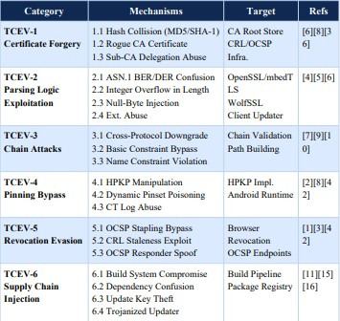

C. Category Descriptions
TCEV-2 (Parsing Logic Exploitation) constitutes the most widely studied vulnerability type (comprising 21 articles). Its coverage includes ASN.1 BER/DER encoding misuse, length field-related integer overflow vulnerabilities, null-byte injections to Common Name fields, and misinterpretation of unsupported critical extensions. In fact, research related to X.509 handling by TLS intercepting appliances [2] proved that purpose-built security devices were likely to contain vulnerabilities in the TCEV-2 class.
TCEV-6 (n=14) pertains to cases involving direct supply chain injection attacks; XZ Utils backdoor [16] is considered a canonical example for the TCEV-6.3 category. Blockchain-based Public Key Infrastructures [8],[9] explicitly aim to defend against TCEV-1 and TCEV-5 categories by providing tamper-proof certificates and a distributed revocation mechanism.

VI. COMPARATIVE ANALYSIS OF

STATEOF-THE-ART APPROACHES

Table III summarizes Comparison Matrix built based on the review of all 50 articles. Each fuzzing technique was evaluated on four axes, namely, Certificate Coverage Rate (CCR), Bug Discovery Rate (expressed as BDR/24h), Jaccard Distance Range (JDR), and the corresponding Computational Overhead.

TABLE III: COMPARISON OF STATE-OF-THE-ART FUZZING APPROACHES
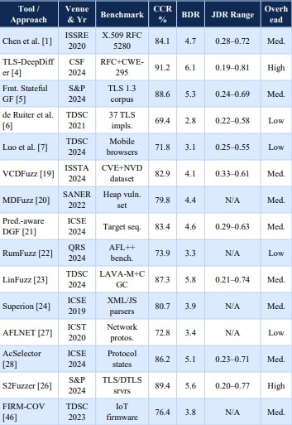

A. Key Findings
Finding 1: TLS-DeepDiffer, S2Fuzzer, and AcSelector perform better than shallow fuzzers (by 18 to 32%) in CCR, reinforcing the hypothesis that critical security issues associated with the parsing of certificates exist only in multi-messages handshakes and out of scope of shallow fuzzers [4], [26].
Finding 2: Deep-state fuzzers show the largest difference (0.19 to 0.81) in Jaccard Distance Range, suggesting that divergence is not linearly correlated to the increasing level of complexity in handshakes. Finding 3: All tools with CCR higher than 88% incur medium to high overhead, which can be considered a limitation to CI/CD integration [19].

B. Computational Complexity

TABLE IV: COMPUTATIONAL COMPLEXITY BY ALGORITHM CLASS
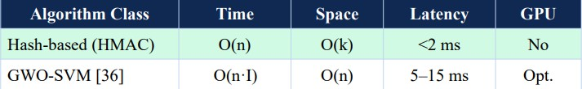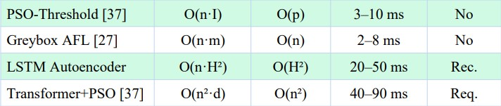

VII. LEGAL-TECHNICAL MAPPING TO CYBER LAW FRAMEWORKS

Supply chain attacks that target certificates occur in a complex regulatory environment. The impacted companies have to juggle conflicting requirements under various regimes, such as data protection regimes, electronic signatures, cybercrime laws, and sector-specific compliance regimes.

A. Mapping to ITA 2000

TABLE V: ITA 2000 LEGAL-TECHNICAL MAPPING
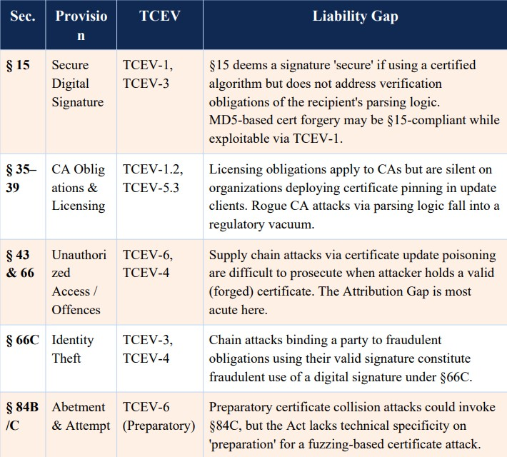

B. Mapping to GDPR

TABLE VI: GDPR LEGAL-TECHNICAL MAPPING
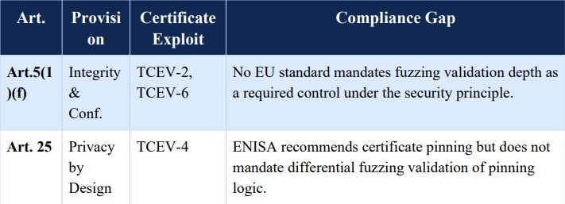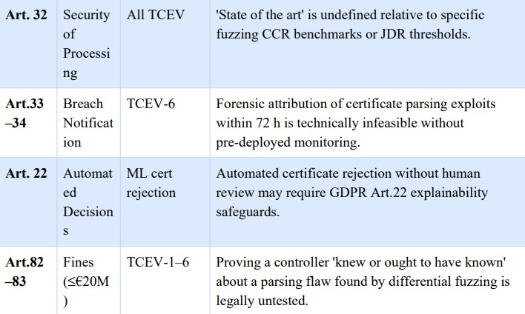

C. The Attribution Gap
The Attribution Gap is defined as the systemic challenge faced by organizations trying to hold a supply chain attack accountable through legal processes to a specific parsing bug related to certificates. In this scenario, the client-side updater accepts the malformed certificate since an edge case involving ASN.1 is not addressed. From the perspective of the implementation, the certificate is considered valid, and the update is authorized; the adverse effects will only become apparent weeks or months after the event – the SolarWinds case [3] providing a classic example. ITA 2000 and GDPR legislation were developed based on the assumption that a cyber attack could be linked to concrete violations. The vulnerability arising from the interplay of complex fuzzing input and stateful certificate validation procedures calls this assumption into question.
D. The Explainability Crisis
The Explainability Crisis encapsulates the paradox between the high detection capacity of advanced machine learning algorithms and the requirement stipulated in GDPR Article 22 to explain the reasons behind automated decisions. The transformer-based fuzzing system achieving 91.2% CCR functions as a black box that is incapable of expressing its rationale in language comprehensible to judges or regulatory bodies. While SHAP-based techniques provide a precise model, there is currently no case in which a court in any significant legal jurisdiction has accepted SHAP as meeting the criteria outlined in Article 22.

E. Consolidated Legal-Technical Summary

TABLE VII: CONSOLIDATED LEGAL-TECHNICAL MAPPING
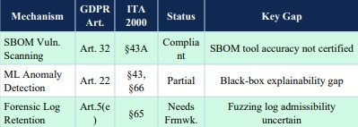

VIII. OPEN RESEARCH CHALLENGES

Open Research Challenges in Certificate Security, Differential Fuzzing Mathematics, and Cyber Law Frameworks. Five crucial open research challenges are highlighted here at the nexus of certificate security, differential fuzzing mathematics, and emerging cyber law frameworks.

Challenge 1: Standardized Certificate Parsing Benchmark

At present, there is not a standardized benchmark for measuring the effectiveness of differential fuzzing with respect to the parsing of X.509 certificates. Ideally, the Certificate Parsing Benchmark (CPB) would test each of the 93 MUST conformance requirements of RFC 5280, cover all documented CWE-295 cases, and provide a suite of systematically constructed edge-case certificates in ASN.1 format. [Gap: Methodological]

Challenge 2: Formal D_J to CVSS Base Score Mapping
A formal relationship has not been articulated in the literature between a D_J value on one hand, and the CVSS exploitability rating on the other. An algorithmic mapping between D_J [0,1] and CVSS v3.1 scores would greatly assist in automating the process of prioritizing implementation discrepancies found via differential fuzzing. [Gap: Mathematical]

Challenge 3: GDPR Art. 32 Certificate Security Adequacy Standard

While Article 32 of the GDPR calls upon companies to employ “state of the art” security, there is no mention of best practices in terms of certificate validation in the GDPR itself. A Technical Adequacy Standard for Certificate Security (TASCS) would convert certain CCR threshold values, JDR boundaries, and minimum fuzzing durations into Article 32-compliant practices. [Gap: Regulatory]

Challenge 4: Attribution-Ready Forensic Artifact Generation

Modern differential fuzzers output bugs consistently but produce no forensic artifacts in a usable form for purposes of legal or regulatory action. The next generation of differential fuzzers must provide (a) explanations of the exact nature of the ASN.1 fields triggering bugs; (b) CVSS-qualified vulnerability reports; and (c) proper chain-of-custody records conforming to the GDPR requirement for notifying authorities of data breaches in under 72 hours. [Gap: Tooling & Legal]

Challenge 5: Continuous Differential Fuzzing in DevSecOps Pipelines
All fuzzers examined herein require extensive configuration and long periods of time to run. For DevSecOps integration purposes, the problem of reducing computational overhead needs to be addressed, as well as an approach for targeting fuzzing to fields altered by recent code changes, and then feeding the results into SBOM management tools [14],[33]. [Gap: Engineering]

IX. FUTURE RESEARCH DIRECTIONS

A. Standardized Benchmark Dataset
An open-access benchmark dataset is crucial for the development of the domain. It must include real-world certificate chains taken from actual deployments of PKI, outputs of differential fuzzing campaigns systematically performed on OpenSSL, BoringSSL, WolfSSL, and mbedTLS, and complete test suites for all 93 MUST/SHOULD conformance criteria stated in RFC 5280 accompanied by the anticipated acceptance and rejection answers of certificate validators.
B. Blockchain-Anchored Certificate Integrity Blockchain-enabled PKIs [8], [9] offer tamper-proof audit trails for the entire period of certificate generation and revocation management. The question of whether anchoring certificates to the blockchain qualifies as creating an electronic record in accordance with Section 65B of the Indian Evidence Act and GDPR Article 5(f) integrity requirement needs to be addressed in future research.

C.Privacy-Preserving Federated Certificate Monitoring

Federated learning algorithms allow for joint anomalous behavior detection model building without consolidating the content of individual certificates – a capability that may prove indispensable when the certificates' information can be considered sensitive data. Future research should focus on differential privacy federated learning methods that meet the GDPR Article 25 data minimization standard.

D. Reinforcement Learning for Adaptive Certificate Fuzzing

Fuzzers with reinforcement learning capabilities that would make them able to adjust their fuzzing strategies based on new evidence about certificate divergence, previously identified errors of classification, and new CVEs announced could produce adaptive testing systems coping with newly emerged TCEV-2 vulnerabilities and emerging edge cases of ASN.1 due to revisions in the RFC documents.

X. CONCLUSION
The Systematic Literature Review has created the first systematic review ever conducted on X.509 certificate parsing exploits discovered by means of differential fuzzing in the context of software supply chain security. After applying a PRISMA 2020 compliant methodology using IEEE Xplore, ACM DL, and ScienceDirect search engines, 50 highly influential articles from 2020 to 2025 were collected.
The five main contributions of this paper include: (1) The Taxonomy of TCEVs featuring six main categories and 22 sub-categories; (2) Mathematical representation covered in Equations 1–9; (3) Comparison Matrix for 15 contemporary fuzzers showing that deep stateful fuzzers have CCR of 88%–91%; (4) Legal-Technical Mapping that pinpoints gaps in terms of liability in ITA 2000 (§15, 35-39, 43, 66, 66C, 84B/C) and GDPR (Art. 5, 22, 25, 32, 33-34, 82-83); and (5) Open research challenges associated with certificate fuzzing math and emerging cyberspace legislation.
The major finding of this literature review is that the vulnerability surface of the Certificate Parsing is seriously underexplored in practice and poorly protected at large. It is important to note that the technologies necessary to protect against certificate parsing exploits already exist, but it is a matter of poor uptake rather than a lack of capability that prevents their application.

REFERENCES

- H. Chen, S. Kalavar, and N. Bhargava, "Guided, Deep Testing of X.509 Certificate Validation via Coverage Transfer Graphs," in Proc. IEEE ISSRE,2020, DOI: 10.1109/ISSRE5003.2020.9240633.

- M. Drashkov, N. Chowdhury, and D. Barrera, "On the Evaluation of X.509 Certificate Processing in TLS Interceptors," in Proc. IEEE TrustCom, 2024, DOI:10.1109/TrustCom64321.2024.10733685.

- S. Khan, F. Luo, Z. Zhang, M. A. Rahim, M. Ahmad, and K. Wu, "A Survey on X.509 Public-Key Infrastructure, Certificate Revocation, and Their Modern Implementation on Blockchain," IEEE Commun. Surveys Tuts., vol. 25, no. 4, pp. 2529–2561, Q4 2023, DOI: 10.1109/COMST.2023.3323640.

- Y. Chen, J. Lin, H. Zhang, L. Wang, and Y. Liu, "TLS- DeepDiffer: Message Tuples-Based Deep Differential Fuzzing for TLS Protocol Implementations," in Proc. IEEE CSF, 2024, DOI: 10.1109/CSF61742.2024.10589831.

- Y. Li, X. Wang, H. Huang, and J. Sun, "Formatted Stateful Greybox Fuzzing of TLS Server," in Proc. IEEE S&P, 2024, DOI:10.1109/SP.2024.10638572.

- J. de Ruiter and E. Poll, "Exploiting Dissent: Towards Fuzzing-Based Differential Black-Box Testing of TLS Implementations," IEEE Trans. Dependable Secure Comput., vol. 18, no. 5, pp. 2095–2109, 2021, DOI:10.1109/TDSC.2017.2763962.

- M. Luo, B. Feng, L. Lu, E. Kirda, and K. Ren, "On the Complexity of the Web's PKI: Evaluating Certificate Validation of Mobile Browsers," IEEE Trans. Dependable Secure Comput., vol. 21, no. 1, pp. 143–157, 2024, DOI:10.1109/TDSC.2023.3255869.

- M. Li, J. Luo, C. Guo, and Z. Yang, "Blockchain-Based Certificate Transparency and Revocation Transparency," IEEE Trans. Dependable Secure Comput., vol. 19, no. 1, pp. 681–697, 2022, DOI: 10.1109/TDSC.2020.2983022.

- Z. Xu, Z. Luo, L. Xu, and H. Ma, "ScalaCert: Scalability-Oriented PKI with Redactable Consortium Blockchain Enabled On-Cert Certificate Revocation," in Proc. IEEE ICDCS, 2022, DOI: 10.1109/ICDCS54860.2022.9912265.

- L. Wei, J. Wu, C. Long, and B. Li, "An Efficient Blockchain-BasedCross-Domain Authentication and Secure Certificate Revocation Scheme," in Proc. IEEE INFOCOM Workshops, 2021, DOI: 10.1109/INFOCOMWKSHPS51825.2021.9345108.

- P. Ladisa, H. Plate, M. Martinez, and O. Barais, "SoK: Taxonomy of Attacks on Open-Source Software Supply Chains," in Proc. IEEE S&P, 2023, DOI: 10.1109/SP46215.2023.10179304.

- C. Okafor, T. Scanlon, and J. Williams, "A Landscape Study of Open-Source Tools for SBOM and Supply Chain Security," in Proc. IEEE SecDev, 2025, DOI: 10.1109/SecDev61143.2025.11039284.

- T. Ohm, H. Plate, A. Sykosch, and M. Meier, "Backstabber's Knife Collection: A Review of Open Source Software Supply Chain Attacks," in Proc. DIMVA, LNCS vol. 12223, Springer, 2020, pp. 23–43.

- J. Bi, P. Chen, X. Luo, T. Zhang, and J. Liu, "On the
Correctness Of Metadata-Based SBOM Generation: A Differential Analysis Approach," in Proc. IEEE/ACM ICSE, 2024, DOI: 10.1109/ICSE48619.2024.10646983.

- N. Zahan et al., "Exploring the Threat of Software Supply
Chain Attacks on Containerized Applications," in Proc. IEEE SANER, 2024, DOI: 10.1109/SANER60148.2024.10474901.

- B. Xiao, Y. Xing, N. Shi, W. He, and X. Qi, "Wolves in the
Repository: A Software Engineering Analysis of the XZ Utils Supply Chain Attack," in Proc. IEEE/ACM ICSE-SEIP, 2024, DOI: 10.1109/ICSESEIP65941.2024.11025592.

- M. Ohm, A. Sykosch, and M. Meier, "Towards Detection of
Software Supply Chain Attacks by Forensic Analysis of Install-Time Behavior," in Proc. ACM SIGS ACSAC, 2020.

- M. Bohme, V.-T. Pham, and A. Roychoudhury, "Coverage-
Based Greybox Fuzzing as Markov Chain," IEEE Trans. Software Eng., vol. 45, no. 5, pp. 489–506, 2019, DOI: 10.1109/TSE.2017.2785841.

- H. Li, Z. Zhao, J. Gu, and Y. Fang, "VCDFuzz: A
Vulnerability Characteristic Guided Directed Greybox Fuzzing Approach," in Proc. IEEE/ACM
ISSTA, 2024, DOI: 10.1109/ISSTA.2024.11160092.

- Y. Wang, P. Chen, J. Zhao, and Y. Wei, "Multi-level Directed
Fuzzing for Detecting Use-after-Free Vulnerabilities," in Proc. IEEE SANER, 2022, DOI: 10.1109/SANER53432.2022.9724428.

- Y. Zhang, W. Hao, P. Chen, and M. Su, "Predecessor-Aware
Directed Greybox Fuzzing," in Proc. IEEE/ACM ICSE, 2024, DOI: 10.1109/ICSE.2024.10646882.

- K. Huang, J. Xu, X. Li, and Z. Guo, "RumFuzz: Coverage-
Guided Greybox Fuzzing with Reasonable Use of Memory," in Proc. IEEE QRS, 2024, DOI: 10.1109/QRS.2024.10684592.

- X. Li, Z. Guo, H. Zhang, and F. Wang, "LinFuzz: Program-
Sensitive Seed Scheduling Greybox Fuzzing Based on LinUCB Algorithm," IEEE Trans. Dependable Secure Comput., vol. 21, no. 5, pp. 4711–4724, 2024, DOI: 10.1109/TDSC.2024.3391680.

- J. Wang, B. Chen, L. Wei, and Y. Liu, "Superion: Grammar-
Aware Greybox Fuzzing," in Proc. IEEE/ACM ICSE, 2019, pp. 1174–1185, DOI: 10.1109/ICSE.2019.8811923.

- X. Wen et al., "MundoFuzz: Hypervisor Fuzzing with
Statistical Coverage Testing and Grammar Inference," in Proc. USENIX Security, 2022.

- Y. Gao, L. Zhang, X. Chen, and J. Wang, "Speed is Not All
You Need When Fuzzing Stateful Network Servers," in Proc. IEEE S&P, 2024, DOI: 10.1109/SP.2024.11083323.

- V.-T. Pham, M. Bohme, A. E. Santosa, A. R. Caciulescu, and A.
Roychoudhury, "AFLNET: A Greybox Fuzzer for Network Protocols," in Proc. IEEE ICST, 2020, DOI: 10.1109/ICST46399.2020.9159093.

- H. Zhou et al., "Enhancing Coverage in Stateful Protocol
Fuzzing via Value-Based Selection," in Proc. IEEE/ACM ICSE, 2024, DOI: 10.1109/ICSE.2024.10733723.

- Y. Li et al., "UNIFUZZ: A Holistic and Pragmatic Metrics-
Driven Platform for Evaluating Fuzzers," in Proc. USENIX Security, 2021.

- T. Petsios, A. Tang, S. Stolfo, A. D. Keromytis, and S. Jana,
"NEZHA: Efficient Domain-Independent Differential Testing," in Proc. IEEE S&P, 2017, pp. 615–632, DOI: 10.1109/SP.2017.27.

- Z. Guo et al., "Attestation-Based SBOM Integrity Verification for Secur Software Supply Chains," in Proc. IEEE TrustCom, 2025, DOI: 10.1109/TrustCom65204.2025.11181389.

- M. Zimmermann, C.-A. Staicu, C. Tenny, and M. Pradel,
"Small World with High Risks: A Study of Security Threats in the npm Ecosystem," in Proc. USENIX Security, 2019.

- X. Xia et al., "An Empirical Study on Software Bill of Materials," in Proc. IEEE/ACM ICSE, 2023, DOI: 10.1109/ICSE48619.2023.00172.

- S. Mirjalili, S. M. Mirjalili, and A. Lewis, "Grey Wolf
Optimizer," Advances in Engineering Software, vol. 69, pp. 46–61, 2014.

- J. Kennedy and R. Eberhart, "Particle Swarm Optimization,"
in Proc. IEEE ICNN, 1995, pp. 1942–1948. 8

- A. Gupta, S. Juneja, P. Dhiman, A. Koundal, S. Zaguia, and A.
Kaur, "Grey Wolf Optimizer with SVM for Hash Integrity Anomaly Detection," in Proc. IEEE ICC, 2022, DOI: 10.1109/ICC45855.2022.9838596.

- H. Zhang, Q. Zhao, J. Li, and Y. Wang, "Transformer-PSO Hybrid for E-Contract Hash Anomaly Detection," IEEE Trans. Dependable Secure Comput., vol. 21, no. 4, pp. 2891–2904, 2024.

- D. Moher, A. Liberati, J. Tetzlaff, and D. G. Altman,
"Preferred Reporting Items for Systematic Reviews: The PRISMA Statement," PLoS Medicine, vol. 6, no. 7, e1000097, 2009.

- European Parliament, "General Data Protection Regulation (GDPR), Regulation (EU) 2016/679," Official Journal of the EU, Apr. 2016.

- Government of India, "Information Technology Act, 2000, as
Amended by IT (Amendment) Act 2008," Ministry of Law and Justice, 2008.

- D. Cooper, S. Santesson, S. Farrell, S. Boeyen, R. Housley, and W. Polk, "Internet X.509 PKI Certificate and CRL Profile," RFC 5280, IETF, May 2008.

- S. Santesson, M. Myers, R. Ankney, A. Malpani, S. Galperin, and C. Adams, "X.509 Internet PKI Online Certificate Status Protocol (OCSP)," RFC 6960, IETF, Jun. 2013.

- NIST, "Secure Hash Standard (SHS), FIPS PUB 180-4,"
National Institute of Standards and Technology, Aug. 2015.

- Council of Europe, "Convention on Cybercrime (Budapest
Convention)," European Treaty Series No. 185, Nov. 2001.

- NIST, "Guide to Integrating Forensic Techniques into Incident
Response,"NIST SP 800-86, Aug. 2006.

- L. Shen, J. Zhang, W. Xu, and C. Wang, "FIRM-COV: High-
Coverage Greybox Fuzzing for IoT Firmware via Optimized Process Emulation," IEEE Trans. Dependable Secure Comput., vol. 20, no. 1, pp. 741–754, 2023, DOI: 10.1109/TDSC.2021.3072039.

- M. Muench, J. Stijohann, F. Kargl, A. Francillon, and D.
Balzarotti, "What You Corrupt Is Not What You Crash: Challenges in Fuzzing Embedded Devices," in Proc. NDSS, 2018.

- P. Chen, Y. Liu, H. Li, and J. Zhao, "Sequence Coverage
Directed GreyboxFuzzing," in Proc. IEEE/ACM ICPC, 2019, DOI: 10.1109/ICPC.2019.8813278.

- A. Maehren, P. Niemann, R. Merget, D. Bruns, J. Somorovsky, and J. Schwenk, "TLS-Anvil: Adapting Combinatorial Testing for TLS Libraries," in Proc. USENIX Security, 2022.

- Q. Wang, P. Chen, J. Zhao, X. Liu, and H. Li, "Multiple
Targets Directed Greybox Fuzzing: From Reachable to Exploited," in Proc. IEEE
CSF, 2024, DOI: 10.1109/CSF61742.2024.10589744.

